**Understanding the EOSIO Platform**

EOSIO is an open-source blockchain protocol designed to enable secure data transfer and high-performance decentralized applications (dApps). Created by Block.one, it's one of the most powerful infrastructures for decentralized applications in the blockchain world today. EOSIO operates as a smart contract platform and decentralized operating system intended to deploy, upgrade, and secure dApps on a large scale.

**Key Features**

The main features of the EOSIO platform are:

*• *Performance* -* It can support up to millions of transactions per second and has very low latency ranging from less than 1 second. This speed and latency make it suitable for real-time applications.

*• *Scalability* -* It uses a delegated proof-of-stake (DPOS) consensus algorithm which involves elected block producers that take turns producing new blocks. This allows it to scale to thousands of transactions per second.

*• *Free to Use* -* It is free and open-source software. Developers can build and deploy applications on EOSIO at no cost.

*• *Smart Contracts* -* It provides a smart contract programming language called WasmSpirit which is based on WebAssembly (WASM). This enables developers to write smart contracts in different programming languages and compile them to WASM for the EOSIOVM.

*• *Ability to Fork* -* Developers can fork the EOSIO core codebase and customize it for their applications while still remaining compatible with the EOSIO ecosystem.

*• *Resource Usage Model* -* Transaction fees are based on the amount of CPU/network resources used rather than arbitrary fees set by the network.

*• *Upgradable* -* System contracts and parameters can be upgraded without the need for hard forks. This makes it easy to upgrade the network over time.

**The EOSIO Architecture**

EOSIO has a unique architecture that is designed to be both scalable and flexible. The architecture is divided into two key components:

*1. *The Core Layer*:* This includes the basic blockchain software and the EOSIO system contracts. It provides the fundamental building blocks for dApp development.

*2. *The Application Layer*:* This is where dApps are built and run. Developers can use the tools provided by EOSIO to create their own custom applications.

The core layer is designed to be as generic as possible, providing just the essential functionality required for a blockchain system. This design choice makes EOSIO highly adaptable, allowing developers to build a wide variety of applications on top of it.

**The Core Layer**

The core layer of EOSIO consists of the following components:

*- *Nodeos*:* This is the core blockchain node daemon that can be configured with various plugins to run a node. Examples of Nodeos plugins include chain_plugin, net_plugin, and producer_plugin.

*- *Cleos*:* This is a command-line tool that interfaces with the REST API exposed by Nodeos.

*- *Keosd*:* This component securely stores EOSIO keys in wallets.

*- *EOSIO.CDT*:* The EOSIO Contract Development Toolkit (EOSIO.CDT) is a suite of tools used to build and deploy C++ smart contracts.

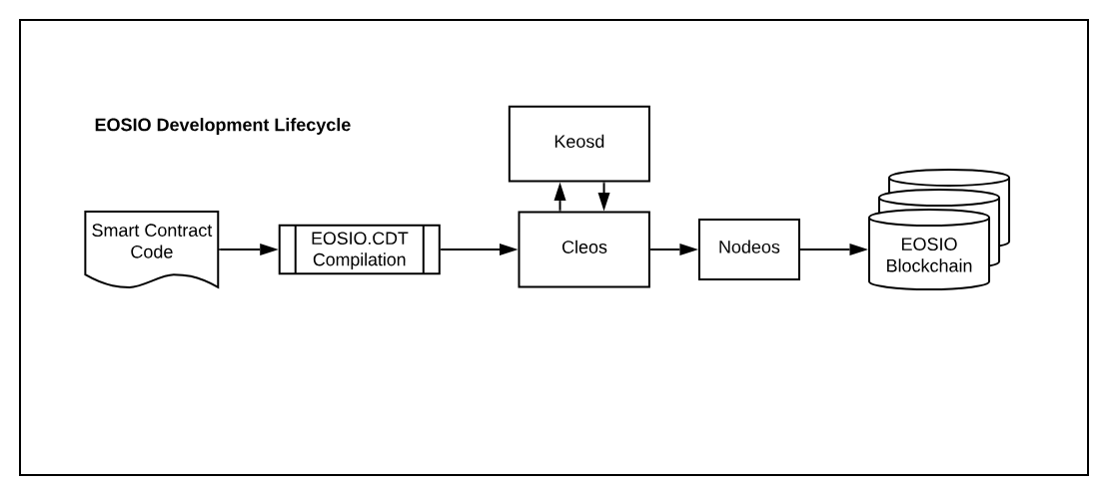

**The Application Layer**

The application layer is where developers build and deploy their dApps. EOSIO provides libraries and SDKs to help developers in this process. Developers can also use the EOSIO Contract Development Toolkit (CDT) to create smart contracts in C++.

Each dApp on EOSIO has its own independent blockchain, which runs parallel to the main EOSIO blockchain. This architecture, known as horizontal scalability, allows for high performance and scalability.

**Consensus Mechanism: Delegated Proof-of-Stake (DPoS)**

EOSIO uses a consensus mechanism called Delegated Proof-of-Stake (DPoS). Unlike traditional Proof-of-Work (PoW) systems, where miners solve complex mathematical problems to validate transactions and create new blocks, DPoS allows EOSIO token holders to vote for "block producers" who generate and validate blocks.

There are 21 active block producers at any given time, but the voting process is continuous, meaning the list of active block producers can change. The DPoS system allows EOSIO to process transactions more quickly than many other blockchains.

**EOSIO Smart Contracts**

Smart contracts on EOSIO are written in C++, a widely-used programming language that offers plenty of resources and support. The EOSIO Contract Development Toolkit (CDT) provides developers with a set of tools and libraries that simplify the process of creating and deploying these smart contracts.

EOSIO smart contracts operate off-chain, meaning they execute on the nodes of the EOSIO network rather than on the blockchain itself. This design choice allows EOSIO to handle a higher volume of transactions and operate more efficiently than many other blockchain systems.

**EOSIO for IoT**

The high scalability, fast transaction times, and the ability to handle a large number of transactions simultaneously makes EOSIO an ideal candidate for IoT (Internet of Things) applications.

In an IoT network, numerous devices need to communicate and interact with each other quickly and effortlessly. EOSIO's architecture is well-suited to this task, as it can process and validate a large volume of transactions rapidly.

Moreover, the transparency and security offered by EOSIO's blockchain technology can be particularly useful in an IoT context. It can help ensure that data exchanged between devices is secure and reliable, and it can provide a clear record of all transactions and interactions between devices.

**How to Get Started with EOSIO**

Getting started with EOSIO involves several steps:

*1. *Installation*:* The first step is to install EOSIO on your system. Detailed installation guides are available on the EOSIO Developer Portal.

*2. *Learn the Basics*:* Familiarize yourself with the basics of EOSIO, such as its architecture, consensus mechanism, and how smart contracts work on EOSIO.

*3. *Start Developing*:* Once you've understood the basics, you can start developing your own dApps or smart contracts. The EOSIO Developer Portal provides various resources to help developers get started, including tutorials, documentation, and sample projects.

*4. *Test Your Applications*:* EOSIO provides a test network called the EOSIO Testnet, where developers can test their applications before deploying them on the main network.

EOSIO offers a powerful and flexible platform for developing high-performance decentralized applications. Its unique architecture, use of C++ for smart contracts, and its Delegated Proof-of-Stake consensus mechanism set it apartfrom many other blockchain platforms. It offers scalability, fast transaction times, and the ability to handle a high volume of transactions, making it an excellent choice for IoT applications.

While understanding EOSIO's architecture and features can be complex, it's worth the effort given the platform's potential. Whether you're a developer looking to build a dApp or an IoT professional interested in leveraging the power of blockchain, EOSIO provides the tools and resources you need to create secure, scalable, and efficient applications.

**Deep Dive into EOSIO Architecture**

The EOSIO architecture operates as a decentralized operating system, which can support large-scale applications without experiencing performance issues. This architecture is divided into several layers, including an application layer where the dApps are run, and a core layer that contains the basic blockchain software and EOSIO system contracts.

**Nodeos**

Nodeos is the main blockchain software for EOSIO. It can be configured with various plugins to run a node. Nodeos includes the following components:

*- *Chain API Plugin*:* This plugin provides HTTP API methods for retrieving blockchain data.

*- *Net Plugin*:* This plugin manages all P2P network message traffic.

*- *Producer Plugin*:* This plugin controls block production.

*- *MongoDB Plugin*:* This plugin allows Nodeos to interact with a MongoDB database.

**Cleos**

Cleos is a command-line interface tool that interacts with the REST API exposed by Nodeos. It's used to deploy and interact with smart contracts on the EOSIO platform, transfer and receive tokens, create accounts, and more.

**Keosd**

Keosd is a component of EOSIO that securely stores private keys in wallets. It's a key server program that communicates with Nodeos through a wallet_plugin.

**EOSIO.CDT**

EOSIO.CDT (Contract Development Toolkit) is a suite of tools used to compile smart contracts into the binary format required by EOSIO. It's used to build and deploy C++ smart contracts on the EOSIO platform.

**EOSIO Consensus Mechanism: Delegated Proof-of-Stake (DPoS)**

One of the unique features of EOSIO is its consensus mechanism: Delegated Proof-of-Stake (DPoS). Unlike Proof-of-Work (PoW) which requires miners to solve complex computational problems to create new blocks, DPoS uses a voting and election process to select block producers.

In the EOSIO DPoS system, token holders vote for block producers, and the top-ranked candidates (typically 21) are chosen as active block producers. These block producers validate transactions and create new blocks.

This consensus mechanism allows EOSIO to process transactions quickly and efficiently, which is particularly useful for high-performance applications such as IoT systems.

**Smart Contracts in EOSIO**

Smart contracts are self-executing contracts where the terms of the agreement are directly written into code. In EOSIO, smart contracts are written in C++, a widely-used programming language.

Using the EOSIO Contract Development Toolkit (CDT), developers can create, deploy, and manage smart contracts on the EOSIO network. The EOSIO.CDT provides a set of tools and libraries that simplify the process of writing smart contracts.

Unlike many other blockchain platforms, smart contracts in EOSIO operate off-chain. This means they execute on the nodes of the EOSIO network, rather than on the blockchain itself. This design allows EOSIO to handle a higher volume of transactions and operate more efficiently.

**EOSIO and IoT**

The Internet of Things (IoT) refers to a network of physical devices that communicate and interact with each other. These devices generate a large volume of data, and managing this data securely and efficiently is a major challenge.

EOSIO's scalable architecture and fast transaction times make it an ideal platform for IoT applications. It can process and validate a large number of transactions quickly, which is crucial for an IoT network where numerous devices need to communicate and interact in real-time.

Moreover, the transparency and security offered by blockchain technology can help ensure that the data exchanged between IoT devices is secure and reliable. This can provide a clear and undeniable record of all transactions and interactions between devices in the network.

**Getting Started with EOSIO**

To get started with EOSIO, you need to follow several steps:

*1. *Installation*:* Install EOSIO on your system. You can find detailed installation guides on the EOSIO Developer Portal.

*2. *Learn the Basics*:* Understand the basics of EOSIO, such as its architecture, consensus mechanism, and how smart contracts work.

*3. *Start Developing*:* Once you're familiar with the basics, you can start developing your own dApps or smart contracts. The EOSIO Developer Portal provides various resources to help you get started, including tutorials, documentation, and sample projects.

*4. *Test Your Applications*:* Before deploying your applications on the main network, test them on the EOSIO Testnet.

**EOSIO supports three storage options for data:**

• Embedded Data Storage - Store small amounts of data directly in account rows on network nodes. This data is automatically replicated.

• External Storage - Accounts can store large data off-chain and maintain a hash/reference to it on the blockchain. This keeps blockchain bloat in check.

• IPFS Integration - Data can be stored decentralized on the Interplanetary File System and accessed via its content-addressable identifiers.